This is a copy of a voucher, Your child's unique code will be in the box at the bottom – **this code is not for use and an example only**

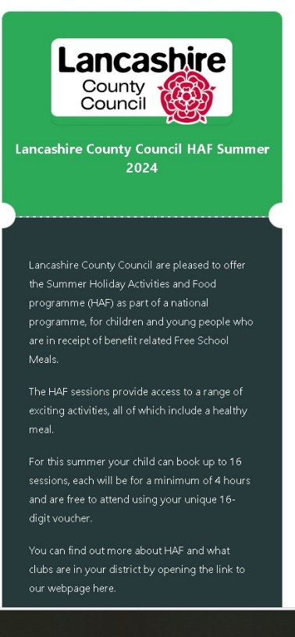

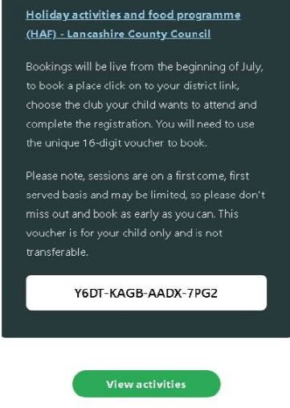

**Look out for your Holiday Activities and Food Programme (HAF) e-voucher**

* If your child is eligible for a funded HAF place you will have received an e-voucher by text or email on the 3rd of July
* This will be from **hello@holidays** who Lancashire County Council have commissioned to send out the vouchers.
* The vouchers will be issued by your child’s school and sent to the contact phone number or email account held by them. This will only be used for holiday e-vouchers.
* The e-voucher will look like this and will have a link to the LCC webpage, from here you can go to your district HAF site, choose a club and book places for your child using the 16-digit HAF code at the bottom of the voucher. This is for you child only and is not transferable.

