**Coverstar**

Coverstar say they are “the safe TikTok alternative.” They state, “there is no specific age limitation…however, if you are under the age of 13, you must obtain parental consent.” Users can post, comment and livestream.

Whilst Coverstar does not include private messaging, users can still interact via public comments. Coverstar does use moderation tools to scan all user-generated content. It is also important to be aware that Coverstar does allow in-app purchases ranging from £0.99 - £59.99.

If your child is using this app, ensure they know how to use the reporting tools. Bark provide a full review of Coverstar here, but they rate it as suitable for 10+: <https://www.bark.us/app-reviews/apps/coverstar-app-review>.

**Online Safety Act**

**What is the Online Safety Act?**

****The Online Safety Act 2023 is a set of laws introduced to protect children and adults online. Ofcom is the regulator for online safety in the UK, responsible for ensuring companies follow the new rules. As part of this role, Ofcom have designed the Children Codes of practice, which came into force in July 2025. The codes outline what all online services likely to be accessed by children must do to protect children online, for example:

* Enforce age limits.
* Protect children from accessing harmful or age-inappropriate content. This includes content relating to self-harm and eating disorders.
* Ensure users can easily report harmful content.

Ofcom has the power to enforce the rules as well as issue fines if companies fail to comply. You can find out more here: <https://www.ofcom.org.uk/online-safety/protecting-children/new-rules-for-a-safer-generation-of-children-online>

**How will it help to protect my child?**

One of the main purposes of the Act is to protect children online. Ofcom has published information on how they are helping children to be safer online. The first link is a guide for parents, which also includes a section on what you can do as a parent. You can access this information here:

**Test your knowledge: Online Scams**

Childnet have created a quiz for 9-13 year-olds that includes a range of potential online scams, as well as tips to help your child protect themselves online. Find out more here:

<https://www.childnet.com/blog/test-your-knowledge-about-online-scams-with-our-quiz-for-9-13-year-olds/>

* <https://www.ofcom.org.uk/online-safety/protecting-children/how-ofcom-is-helping-children-to-be-safer-online-a-guide-for-parents>
* [https://www.ofcom.org.uk/online-safety  
  /protecting-children/how-the-online-safety-act-  
  will-help-to-protect-children](https://www.ofcom.org.uk/online-safety/protecting-children/how-the-online-safety-act-will-help-to-protect-children)

**Further information**

Online Safety Act: explainer:   
[https://www.gov.uk/government/publications  
/online-safety-act-explainer/online-safety-act  
-explainer](https://www.gov.uk/government/publications/online-safety-act-explainer/online-safety-act-explainer)

**Roblox: Grow a Garden**

Roblox is a platform consisting of a collection of games. Grow a Garden is one of the latest games available on Roblox and is extremely popular. The game is labelled as ‘minimal’ for content maturity, which Roblox define as “may contain occasional mild violence, light unrealistic blood, and/or occasional mild fear.” Roblox believe that the game play is suitable for everyone. However, as the game is on Roblox, it is important to be aware of the following:

**- Chat –** strangers can interact with your child.

**- In-game purchases –** this game does include in-game purchases.

- **Screentime –** set limits for how long your child is playing.

**A lot of the content on Roblox is user generated, which may mean not all games will be suitable for your child to view/play.** If your child is playing Roblox, it is important to monitor what your child is accessing, ensure they know how to use any reporting tools and set up appropriate parental controls.

**Further information**

<https://en.help.roblox.com/hc/en-us/articles/30428310121620-Parental-Controls-Overview>

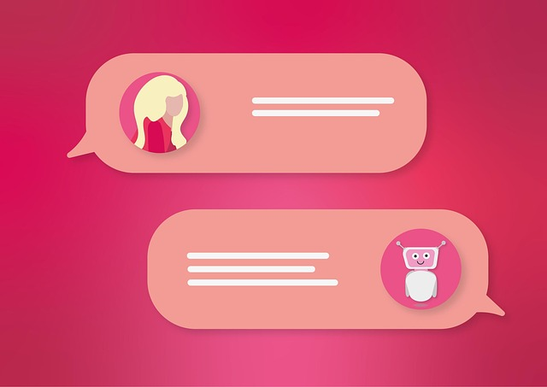

**What is AI?**

AI is when a computer/machine can learn and perform tasks like a human. Its popularity continues to grow, and examples include:

* **Search engines** such as Google now include an AI-generated overview as part of their results.
* **Virtual assistants** like Alexa, Meta AI and Siri.
* **Chatbots** such as ChatGPT and My AI from Snapchat.

**Opportunities**

AI can be an effective tool when used correctly, for instance:

* **Homework –** children can use AI to support and assist their learning.
* **Advice –** AI can be used to provide information and suggestions on a variety of topics.

**Risks and concerns**

* **Misinformation –** ensure your child understands thatAI can sometimes provide incorrect or misleading information.
* **Privacy issues –** read any privacy policies before using.
* **Chat apps -** a simple search of “AI Chat” within the App store highlights the number of apps already available that are not suitable for children as many are rated as 17+.
* **Image manipulation –** there are AI tools that can be used to digitally remove clothes from photos, which clearly raises serious safeguarding and privacy concerns.
* **Deepfakes** – there are also AI tools that create realistic, fake videos that can be used to spread misinformation or cause harm.

**How can I protect my child?**

To help keep your child safe online, it is important to:

**Grooming online**

Grooming is when somebody seeks to build a relationship with a child to exploit them or cause harm.

It is important that we teach our children how to recognise red flags. Childline have lots of useful information on their website, including where to get further support from:

<https://www.childline.org.uk/info-advice/bullying-abuse-safety/online-mobile-safety/online-grooming/>

* Check age ratings of any apps or websites that your child accesses.
* Develop your child’s digital literacy by highlighting the risks of AI and showing them how important it is to verify what they see online.
* Set up appropriate parental controls on their devices/ broadband.
* Chat to your child regularly and ensure your child knows that they should talk to you or another trusted adult if anything concerns them.

**Further information**

* Overview: <https://www.internetmatters.org/advice/by-activity/using-artificial-intelligence/what-is-ai-artificial-intelligence/>
* Should you worry if your child has an AI friend? <https://parentzone.org.uk/article/should-you-worry-if-your-child-has-ai-friend>

*Users of this guide do so at their own discretion. No liability is entered into. Current as of the date released 01.09.25. The inclusion of any links does not imply any affiliation with or endorsement of the linked websites, documents, or videos, nor are we claiming any ownership or copyright in the content of the linked materials.*